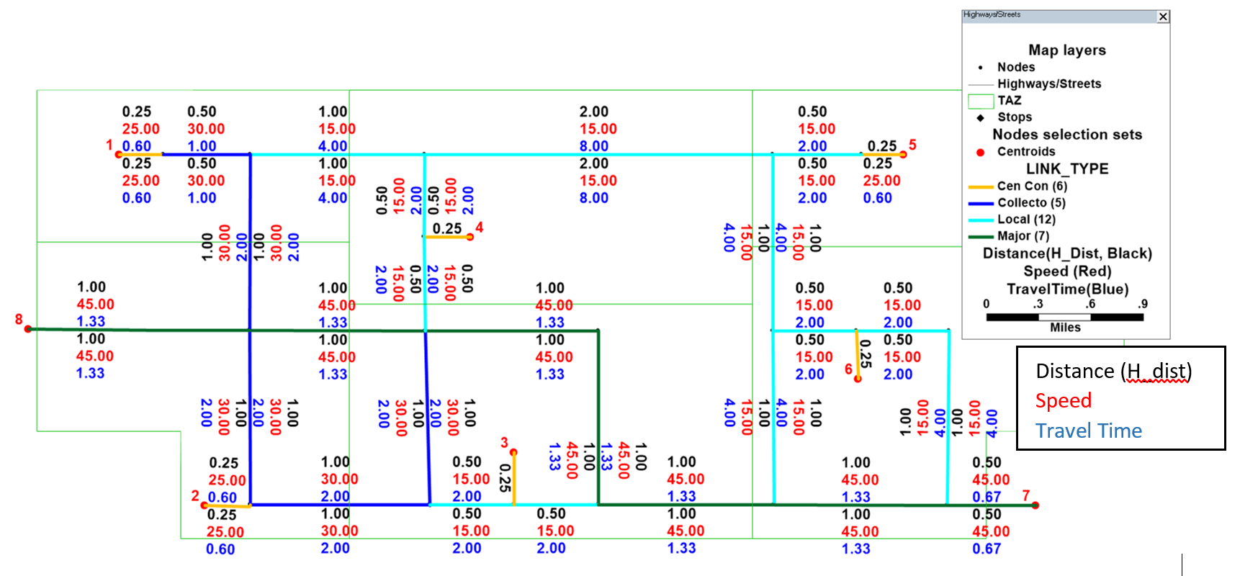

Shortest Path Tree 1
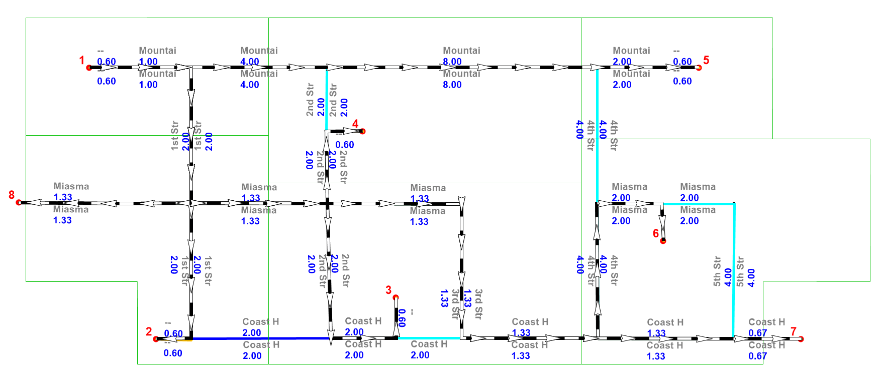
Shortest Path Tree 2
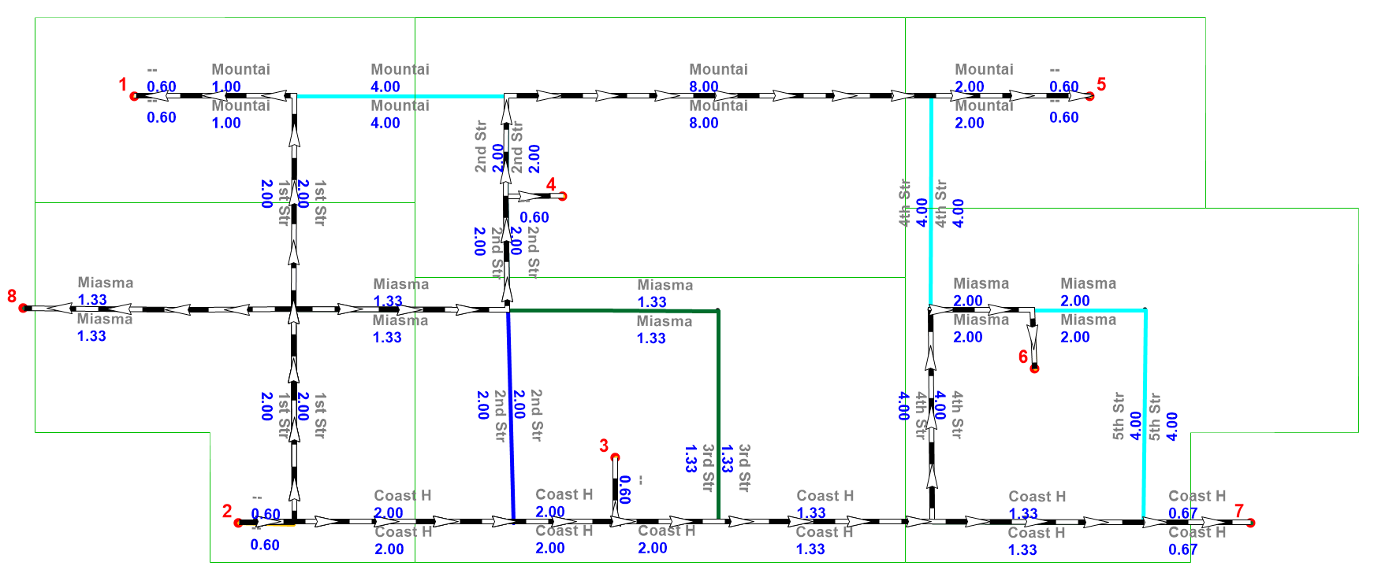
Shortest Path Tree 3
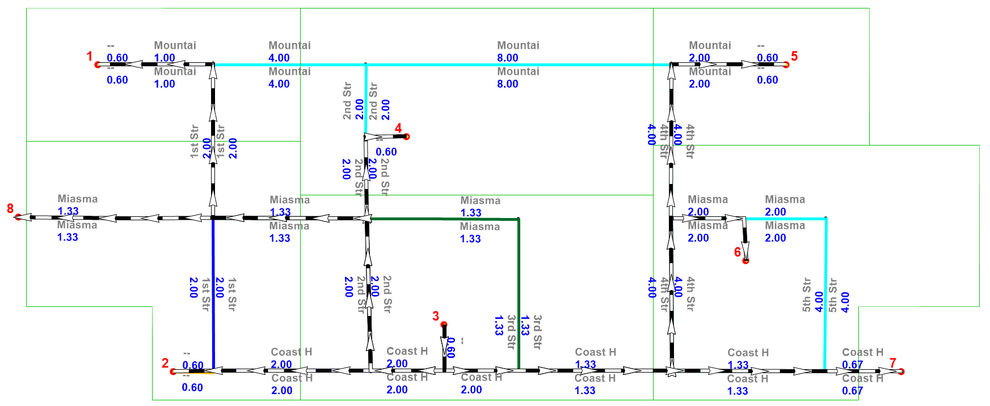

Shortest Path Tree 4
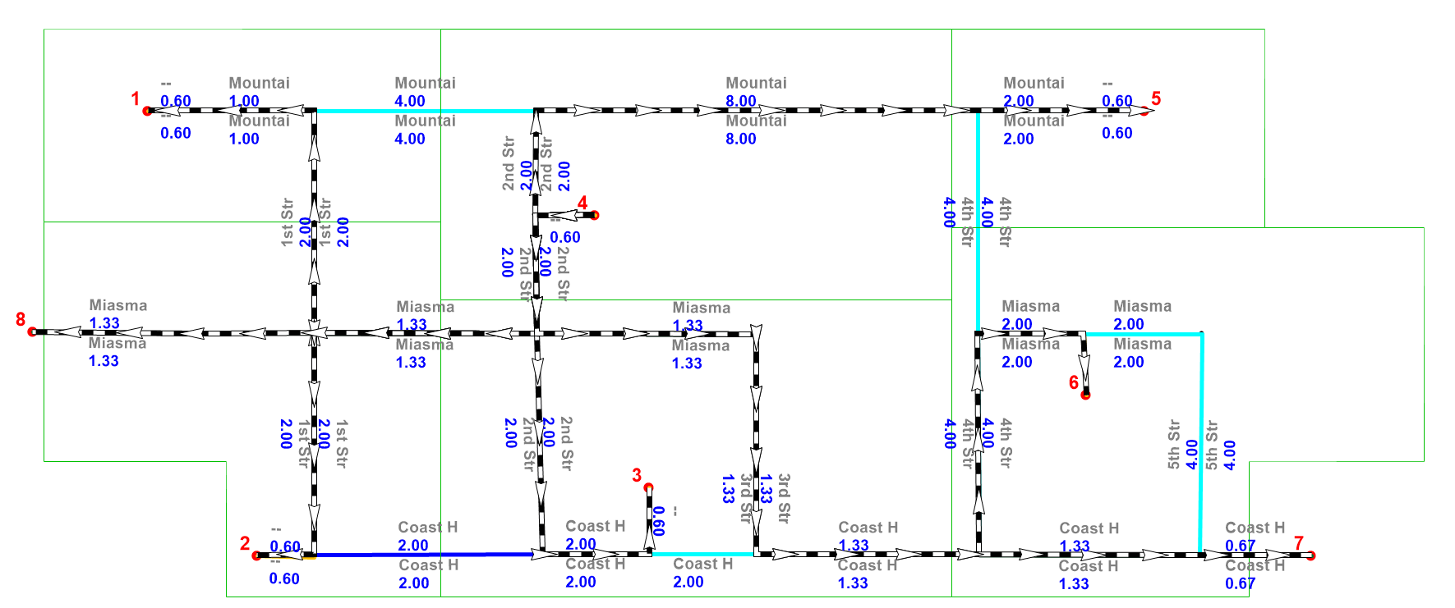
Shortest Path Tree 5
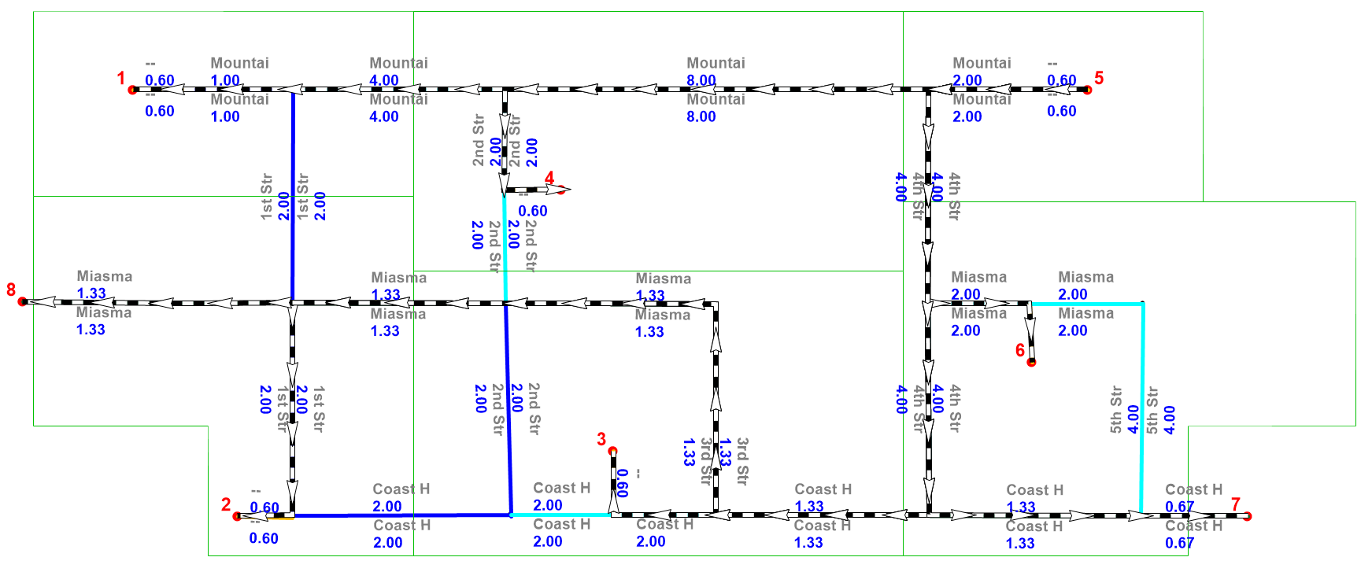
Shortest Path Tree 6
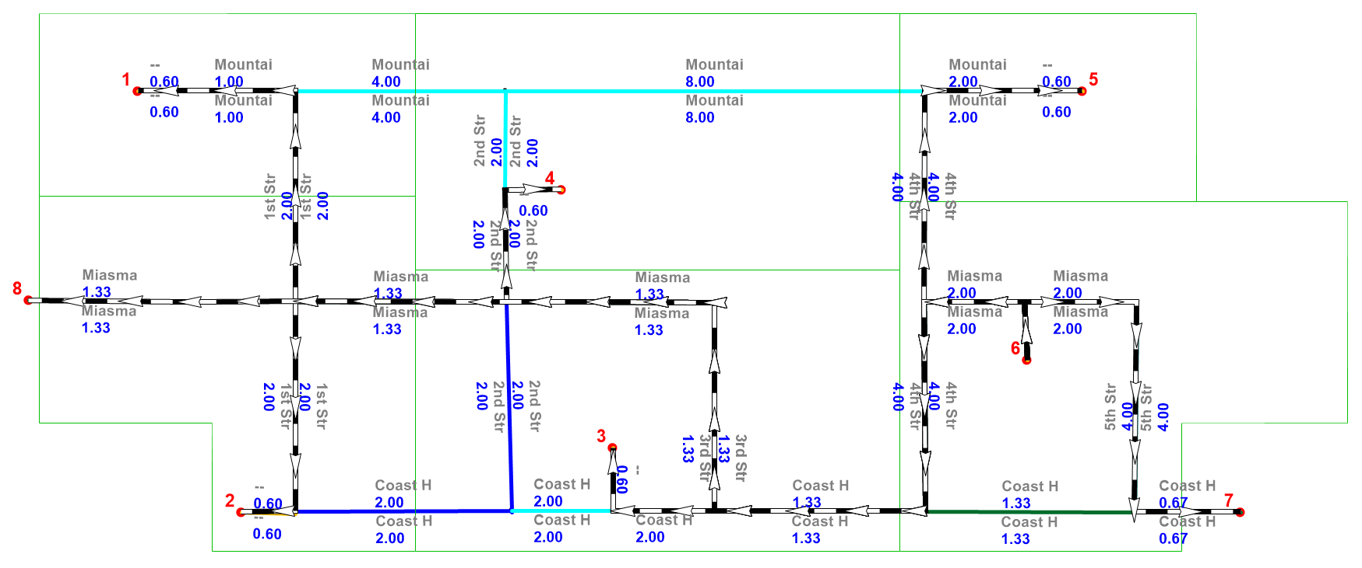
Shortest Path Tree 7
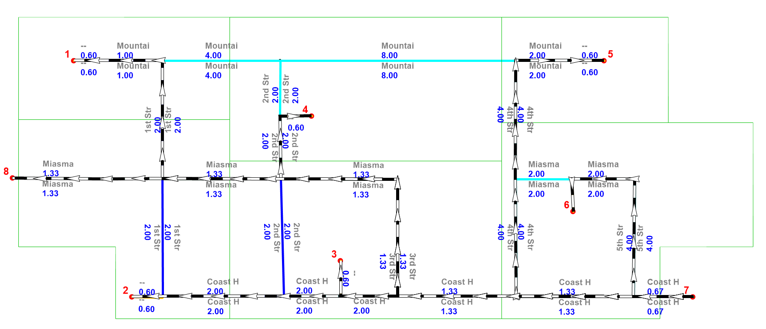
Shortest Path Tree 8
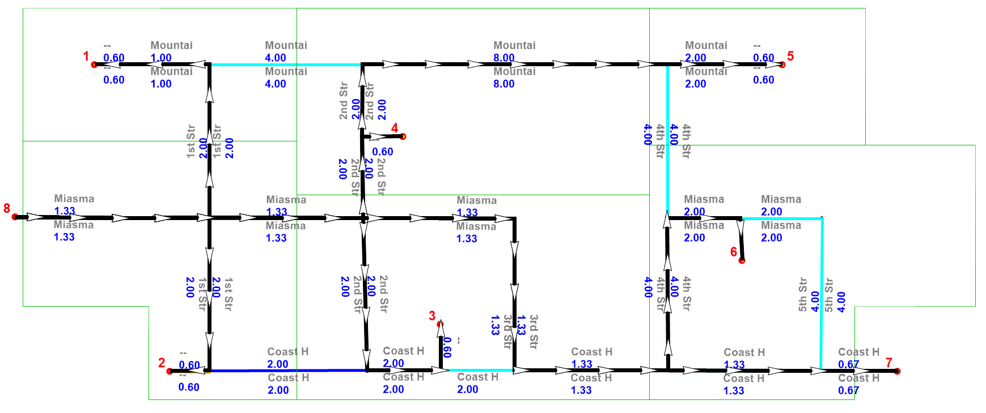

Skim Table 1. Interzonal Times (Spring 2025)
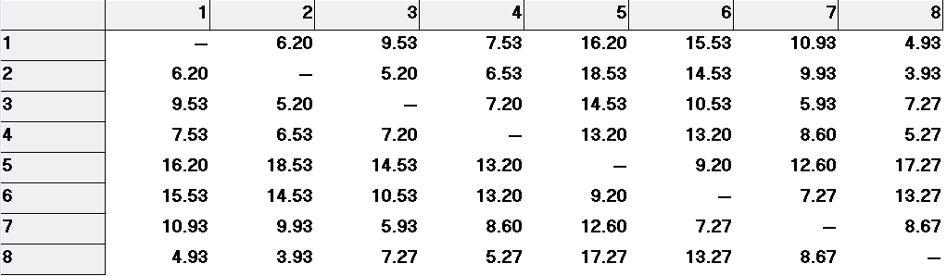
Skim Table 2. Interzonal + Intrazonal Times (Spring 2025)
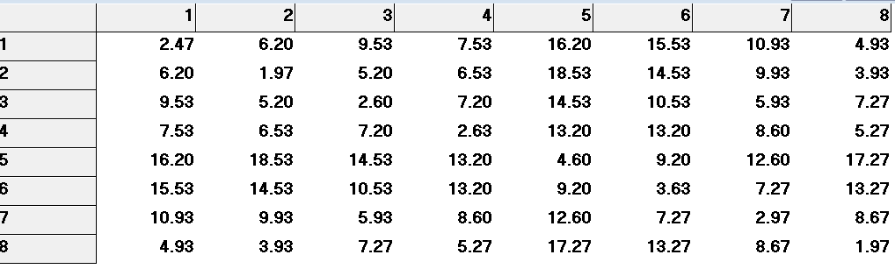
Skim Table 3. Interzonal + Intrazonal + Terminal Times (Spring 2025)
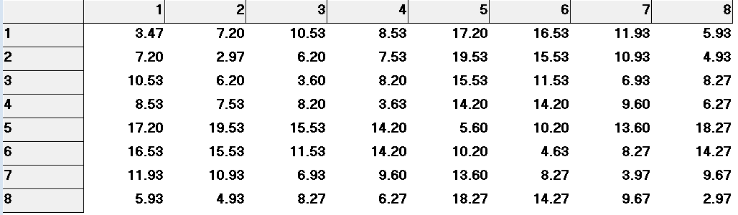
Skim Table 4. Interzonal Distances (Spring 2025)
